

COMPANY RATING WEBSITE

Configuration Management Plan

*Report #1*

|  |  |  |
| --- | --- | --- |
| **COMPANY RATING WEBSITE – *KẾ SINH NHAI TEAM*** | | |
| **Group Members** | Trần Quốc Hưng | SE02970 |
| Nguyễn Sơn Lâm | SE03090 |
| Nguyễn Việt Hùng | SE03293 |
| Nguyễn Nhật Quang | SE03122 |
| Trần Đăng | SE03039 |
| **Supervisor** | Bùi Đình Chiến | |
| **Project code** | CRW | |

**- Hanoi, 29/05/2016 -**

# SIGNATURE PAGE

**AUTHORS**: Trần Quốc Hưng 28/05/2016

*Project Manager*

**REVIEWER**: Nguyễn Sơn Lâm 29/05/2016

*Team Member*

Nguyễn Nhật Quang 29/05/2016

*Team Member*

**APPROVAL**: Bùi Đình Chiến 03/06/2016

*Supervisor*

# Record of change

*A – Added; M – Modified; D – Deleted

|  |  |  |  |  |  |  |
| --- | --- | --- | --- | --- | --- | --- |
| Effective Date | Changed Item | A,M,D* | Change Description | Reason for Change | Rev. Number | |
| 28/05/2016 | Project Plan | A | First version | Create CMPlan | | 1.0 |
|  |  |  |  |  | |  |
|  |  |  |  |  | |  |

Table of Contents

SIGNATURE PAGE 1

Record of change 2

1 INTRODUCTION 4

1.1 Role & Responsibility 4

1.2 Definitions and Acronyms 4

2 CONFIGURATION MANAGEMENT PROCESS 5

2.1 CI Identification & Naming convention 5

2.2 Project Infrastructure 6

2.3 CI Baseline Procedure 7

2.3.1 For Document 7

2.3.2 For Source code 8

2.4 Project Baseline schedule 9

3 Directory structure & Access right 10

3.1 Promotion Area 10

3.2 Directory structure 10

*3.3* Access right control 11

3.4 Version numbering rule 12

3.4.1 For Documents 12

3.4.2 For Software Source Files: 12

3.5 Other CM rules 13

# INTRODUCTION

The purpose of this document is to identify and describe Configuration management (CM) process implemented in the project CRW.

## Role & Responsibility

Refer to Project Organization section in [CRW_Project Plan_v1.0_EN](CRW_Project%20Plan_v1.0_EN.docx)

## Definitions and Acronyms

Table 1‑1: Definitions and Acronyms

|  |  |  |
| --- | --- | --- |
| Acronym | Definition | Note |
| CC | Infrastructure Configuration Controller |  |
| CI | Configuration Item |  |
| CM | Configuration Management |  |
| CRW | Company Rating Website |  |
| PP | Project Plan |  |
| CSCI | Computer Software Configuration Items |  |
| PM | Project Manager |  |
| QA | Quality Assurance Officer |  |
| Source | Source Code |  |
| PIC | Person in Charge |  |
| WIP | Work in Progress |  |
| WP | Work Product |  |

# CONFIGURATION MANAGEMENT PROCESS

## CI Identification & Naming convention

**Table 2‑1:** CI Identification & Naming convention

|  |  |  |
| --- | --- | --- |
| CSCI | Configuration Items | Naming Conventions |
| Project Management | PP | CRW_ProjectPlan_v<x.x>_[language code] |
| CM Plan | CRW_CMPlan_v<x.x>_[language code] |
| Introduction (Report 1) | CRW_Introduction_v<x.x>_[language code] |
| Risk Management | CRW_Risk Management_[language code] |
| Project Schedule | CRW_Project_Schedule_v<x.x>_[language code] |
| Examination | CRW_Examination_v<x.x>_[language code] |
| Requirement & Design | Software Requirement Specification | CRW_SoftwareRequirementSpecification_v<x.x>_[language code] |
| Screen Design | CRW_ScreenDesign_v<x.x>_[language code] |
| Architecture Design | CRW_ArchitectureDesign_v<x.x>_[language code] |
| Class Design | CRW_ClassDesign_v<x.x>_[language code] |
| Data Design | CRW_DataDesign_v<x.x>_[language code] |
| Prototype | Prototype_v<x.x> |
| Build | Source code | CRW_SourceCode_v<x.x>_Tested/Untested |
| Test Plan | CRW_TestPlan_v<x.x>_[language code] |
| System Test Case | CRW_SystemTest Case_v<x.x>_[language code] |
| Integration Test Case | CRW_IntegrationTest_v<x.x>_[language code] |
| Unit Test Case | CRW_UnitTestCase_v<x.x> _[language code] |
| Defect Log Management | CRW_DefectLogManagement_v<x.x>_[language code] |
| Component Test Case | CRW_ComponentTestCase_v<x.x> _[language code] |
| Test report | CRW_TestReport_v<x.x>_[language code] |
| Process | Guideline_Name of guideline | CRW_Guideline_Title of guideline |
| Coding Convention/Standard | CRW_Coding convention |
| Checklist_Name of checklist | Checklist_Title of checklist_v<x.x> |
| Document type | MS Word | ***.docx |
| MS Project | ***.mpp |
| MS Excel | ***.xls |

## Project Infrastructure

Table 2‑2: Project Infrastructure

|  |  |  |  |
| --- | --- | --- | --- |
| Tool | Version | Purpose | Note |
| GitHub Desktop Program | 1.8 | For source control |  |
| Microsoft Visio | 2015 | For visual diagrams |  |
| Microsoft Project | 2015 | For project management |  |
| Astah | 7.0 | For visual diagrams |  |
| Visual Paradigm | 13.2 | For visual diagrams |  |
| Microsoft Office | 2015 | For documentation and presentation |  |
| Hosted Redmine | [Online] | For bug control |  |
| MongoDB | 2015 | For development |  |
| Adobe Illustrator | CS6 | For design |  |
| Sublime Text | 3.0 | For development |  |

## CI Baseline Procedure

### For Document

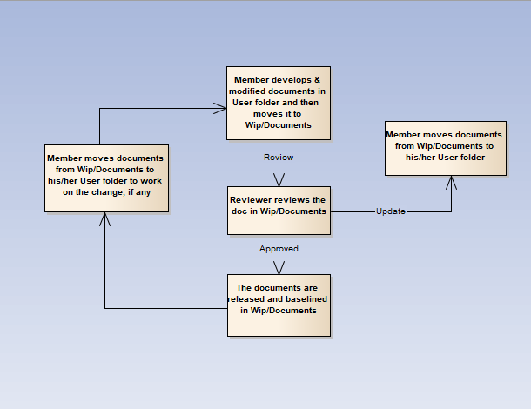

**Figure 2-1:** CI Baseline Procedure for document

### For Source code

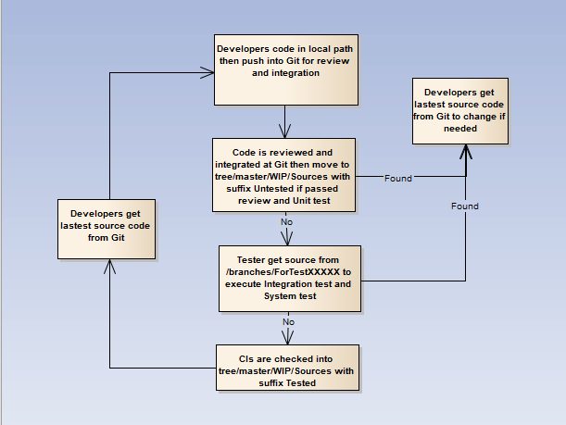

**Figure 2-2:** CI Baseline Procedure for source code

## Project Baseline schedule

**Table 2‑3:** Project Baseline schedule

|  |  |  |  |
| --- | --- | --- | --- |
| No. | Baseline Name | When Baseline | PIC |
| 1 | Initiation | Within 7 days from approval. It is mandatory requirement that CI versions in Startup baseline are to be archived in separate folders in Archive area | Project team |
| 2 | Solution | When Architectural design v1.0 is released | Project team |
| 3 | Construction | At the end of development phase | Project team |
| 4 | Termination | After the final release. It is mandatory requirement that CI versions in Wrap-up baseline to be archived in separate folders in Archive area | Project team |

# Directory structure & Access right

## Promotion Area

Table 3‑1: Promotion Area

|  |  |
| --- | --- |
| Area | Purpose |
| Develop Area | Area for different users to store his/her own items |
| Review Area | For storing review-ready items.  Reviewer gets review-pending items from this area |
| Test Area | Applicable for Source items.  For storing items passed Unit Test and Code Review |
| Release Area | For storing items ready for release and all released versions of items  Users get the latest items from this area |
| Archive Area | For archiving all released versions of each CI  Archive area is a protected area for project baselines where all the CIs cannot be changed by any member |

## Directory structure

**Table 3-2:** Directory structure

|  |  |  |  |  |
| --- | --- | --- | --- | --- |
| Main Folder | Sub Folder | Purpose | Map to Area | Access right |
| Project Directory : | | | | |
| WIP | Documents | Documents of Requirements, Design, Test, … | Release + Review | Full: PM, CC  Modify: PIC  Read: All |
| Deliverables | Document of Reports (1->6) to deliver | Release + Review | Full: PM, CC  Modify: PIC  Read: All |
| Meeting minutes | Store project meeting minutes, including meeting minutes with customer | Release + Review | Full: PM, CC  Modify: All |
| Plan | Store Proposal, Estimation, Project Plans, Project schedule, Task list | Review + Release | Full: PM, CC  Modify: PTL  Read: All |
| Record | Store project records, divided into  Review: include Review, Test and Inspection records  Change request  Acceptance  Mails  ... | NA | Full: PM, CC  Modify: All |
| Sources | Store VSS file of Source code | Archive | Refer to VSS directory |
| Users | User’s working area, store user’s items | Develop | Full: PM, CC  Modify: User  Read: All |
| Reference | Processes | Store Documents and Other materials/data supplied by customer or those support software development and production operation in the project… | Release | Full: PM, CC  Modify: PIC  Read: All |
| Templates | Store Guidelines/Standards/Forms/Templates/Checklist specified for the project usage | Release | Full: PM, CC  Modify: PIC  Read: All |
| Final |  | Final document | Release | Full right: Project QAs  Read right: All |

## Access right control

Access right of non-project team members (ex: auditor, external reviewer, etc…) must have permission gotten from PM and granted in the pre-defined duration, then revoked at expiry date by CC. As soon as a member is out of the project, his or her access right is revoked also.

The access right is reviewed frequently and updated by CC at August 19th, 2016.

After project asset is approved by QA at project closure time, PM informs to Technique Team to revoke the access right of all project team members. If someone has a request for data reference, audit, etc…, he or she must get the approval of authorized person, normally Team Leader, and then send the request to Technique Team. Technique Team is responsible for implementing such kind of requests.

## Version numbering rule

### For Documents

The version level is maintained as numbered identifier with two components

1.1

Revision

Version

The original version will be numbered 0.1. Subsequent revisions will be numbered 0.2, 0.3. The release version will be 1.0.

**Version number**, which appears to the left of the decimal. It changes only when the core architecture of the item changes. For example: when an item is completely overhauled, with substantial internal changes, the version 1.0 would become version 2.0.

**Revision number,** which appears to the right of the decimal. It changes when existing content is changed, but the overall structure and flow of the item remains the same. The normal sequence of revision is 1.1, 1.2 and so on.

### For Software Source Files:

Software executable and support files are generally identified by name and version number, such as “Main DB v1.1.a”. The scratch edition will be 1.0. The version numbering scheme consists of three components:

1.1a

Revision

Version

Update

view

**Version number**, which appears to the left of the decimal. It changes only when the core architecture of the software item changes, as when moving from one area of the development tool to another, when an application is completely overhauled, or the user interface changes fundamentally. In this case, version 1.1a would become version 2.0.

**Revision number**, which appears to the right of the decimal. It changes when new features, functionality or other content are added or significantly changed. In normal case, the core architecture or user interface have been extended or limited in some manner. The most common reason for changing the revision number is when adding a new module or other functionality to the software. The normal sequence of revision is 1.0, 1.1, and 1.2 and so on.

**Update level** is appended or incremented when the only change to the software item is to correct one or more defects, without the addition of any new functionality. Version 1.1 would become v1.1a, v1.1b and so on. This updating is over ridden when a combination revision, involving bug fixes and new feature additions, is performed. In such a case, the software revision number is incremented and any update indicator is dropped, as in v1.1b to v1.2.

## Other CM rules

**Rule for deliverables releases:** When a member releases any WP, he/ she must review carefully, takes review from other member and has clearly comment.

**Rule for changing document:** When a member wants to develop or modify documents, he must copy the documents from Documents folder to User folder to work on the change (if any), then merge it to Document folder with another version and has clearly comment. Members are absolutely not allowed to edit directly on the Project folder.